PLANT MONITORING SYSTEM

ABSTRACT

As we can see in today’s world only some devices like PC’s and mobiles are connected to internet. Now a days days world is fully overtaken by the internet and internet of things. Internet is use for basic need of all human beings. The Internet of Things (IOT) is the network of physical objects. It simply means to monitor a physical device or machine or it is inter-networking of physical devices which is embedded with electronics, sensors, software and network connectivity to enable it to achieve greater value and services by exchanging data with the manufacturer IOT permits objects to be sensed or controlled remotely across the network infrastructure. The result improves accuracy, economic benefits, efficiency and reduces intervention of human.

In this paper we are going to deal with basic and important concepts of IOT and its scope in upcoming future. This paper studies the need of IOT in day to day life for different applications and gives brief information about IOT. IOT contributes significantly toward revolutionary farming methods. So we are trying to demonstrate IOT in Automatic watering system. Automatic watering system monitors and maintain the approximate moisture content in soil. Arduino UNO is used as microcontroller to implement the control unit. The set up uses the temperature sensor, moisture sensor and humidity sensor which measure the approximate temperature, moisture and humidity in the soil. This value enables the system to use appropriate quantity of water which avoids over/under irrigation.

# **AREA OF THE PROJECT PROPOSAL IN SOCIETY**

* AGRICULTURE
* GARDENS
* NURSERY FARMS etc..

In India 83% of water is consumed by agriculture. If there are no plan for the usage of water in farms, then it causes wastage of water.

The plant monitoring system is helpful for watering the plants and to monitor few parameters for growth of plants. This is real time plat monitoring system to view temperature, moisture and humidity. This system is mostly used in few areas like nursery farms and in agriculture.

TECHNICAL SPECIFICATIONS

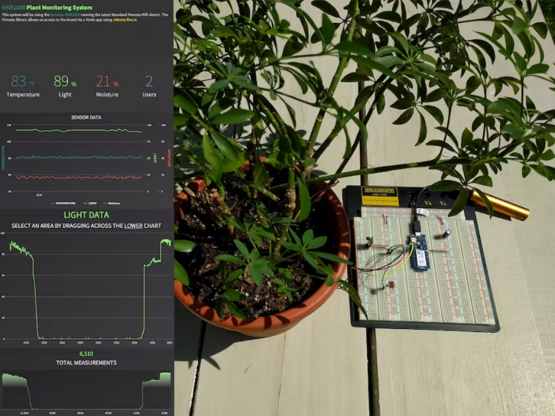

This system is combination of both Hardware and Software Components

**Hardware Components:**

1. Arduino UNO
2. Sensors(Moisture, Temparature,Humidity)
3. Relay
4. Motor
5. Bread Board
6. Wires
7. Batteries

**SOFTWARE USED** :

* JAVA

**The Business(Marketing)**

Primarily our experiment motto is reducing the wastage of water. In addition to that It is real time Plant Monitoring System to temperature, Moisture and Humidity, that’s why we strongly propose this technique mainly in Plant Nurseries. Because Nursery Plant needs more care that can be provided with our technology efficiently. Ofcourse it can be used in Agriculture practice as well and also in gardens who want to moniter their plants daily without fail.